18

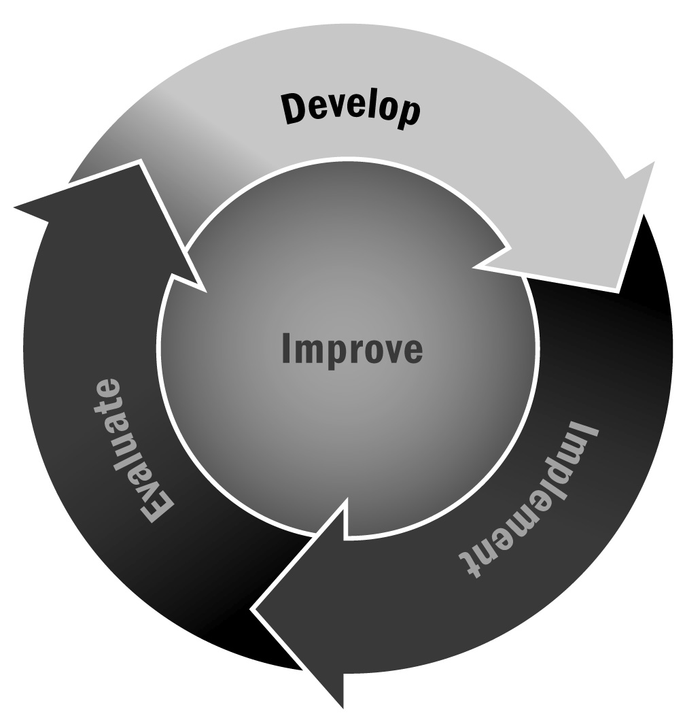
Calculation of In-Kind Contributions
In Chapter 3, you learned that partnerships are vitally important for afterschool and expanded learning programs. Partners contribute many things to programs that are non-monetary in nature. Capturing this information will not only allow you to calculate the true costs of your program but also allow you to determine the monetary value of each of your partnerships.
Directions: Use this tool to calculate the amount and value of in-kind contributions and services that your partners provide to your afterschool and expanded learning program. This information is useful when seeking out additional funding or making presentations about the contributions of partners to the collaborative effort. By calculating the value of these in-kind contributions, you can make a powerful statement about the community’s support and the stability of the program.
 | Item | Value | Contribution Details (Who? What? When?)
Space | - Use the fair rental value. Real estate agents or property managers should be able to give you an estimate of that value. Be sure to include the value of utilities—heating, cooling, electricity, and phone—if they are provided. | $
Goods and Supplies | - Calculate the fair market value of each item (i.e., what it would cost to purchase it). | $
Equipment | - Calculate the fair market value. Check with an equipment rental company to find out what it would cost to rent similar equipment. | $
Personnel Services | - If another agency contributes staff members to your program, you can calculate the value of those staff members by dividing their combined annual salary by 2,080 (the number of hours in a 52-week work year) to obtain the hourly rate, then multiplying by the number of hours of service. The result is the value of their in-kind contribution.  - For volunteers, there are two ways that you can calculate the value of their efforts. For nonprofessional volunteers, use the minimum wage and multiply by the number of hours served. For professional volunteers, use the same formula that you would for personnel services. | $
Other | - Often, partners will do mailings, make copies, and send staff members to meetings. All of these are  in-kind contributions. Be sure to count them. | $
Total In-Kind Contributions |  | $

